
Save me a space…. to secure your place please fill out this form and post it to us with your cheque
for £25 per delegate. Please make cheques payable to Otley College

NAME……………………………………………………………………………………………………………………………………………………………….

FARM/BUSINESS………………………………………………………………………………………………………………………………………………

ADDRESS.………………………………………………………………………………………………………………………………………………………….

TELEPHONE NO…………………………………………………………… EMAIL……………………………………………………………………

2nd Delegate Name……………………………………………………………...........


ERfi, South Green Park Enterprise Centre, Mattishall, Dereham, NR20 3JY 01362 857100



Cost for the Workshop:
£25 per delegate
including lunch

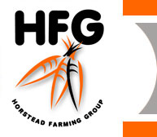
Farm Shop Workshop
Gaining & Keeping Customers

A workshop for those already running a farm shop or thinking of doing so

Wednesday 26th September 2007, 10.00am to 4.00pm
HFG Farm Shop
Nth Walsham Rd, Beeston St Andrew, Norwich, NR12 7BW

The Farm Shop: a chance to look around the farm shop and facilities with a talk by Judy Taylor, Director of HFG, covering her own experiences of turning this shop into the great success it is today
Farm Shop Design & Layout: tips on how to attract customers into your shop, encourage those all important purchases and increase the average spend. (Gareth Jones, FARMA)
Support for Farm Shops: Mike Richardson of EBLEX: an insight into support for distribution, marketing and butchery
How Big is the Market in this Area? Who’s buying what in this area - Paul Mayfield of the Food Chain Centre talks on customer buying patterns in this region drawing on extensive market research into food purchasing habits
Adding Value: Recipe development for higher value offerings in your shop (Mike Richardson, EBLEX) and selling fruit & vegetables locally – a real success story; local veg to local schools (Sam Frosdick)
--------------------------------------------------------------------------------------------------------------------------------------------------
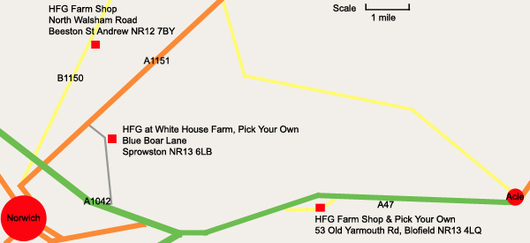

Contact:
Jonathan Whitbread
ERfi
01362 857100
South Green Park,
Mattishall
Dereham
Norfolk
NR20 3JY
www.erfi.co.uk



